NAME:FAHAD KHAN
ROLL NO : 23-SE-64

Qusetion No 1:
Using Built in function:

% Read the image
I = imread('cameraman.tif');

% Bilinear interpolation
J = imresize(I,2,'bilinear');

% Bicubic interpolation
K = imresize(I,2,'bicubic');

% Display images
figure
subplot(1,3,1)
imshow(I)
title('Original Image')

subplot(1,3,2)
imshow(J)
title('Bilinear Interpolation')

subplot(1,3,3)
imshow(K)
title('Bicubic Interpolation')

Using code:
Image1 = imread('cameraman.tif');

rows1 = size(Image1,1);
columns1 = size(Image1,2);

rows2 = rows1*2;
columns2 = columns1*2;

Image2 = zeros(rows2+2,columns2+2);

cx = columns2/columns1;
cy = rows2/rows1;

for x = 2:columns2-1
for y = 2:rows2-1

if(mod(x,2)==0)
v = round(x/cx);
w = round(y/cy);

Image2(y,x) = Image1(w,v);

else
Image2(y,x) = -1;
end

end
end

for x = 2:columns2-1
for y = 2:rows2-1

if(Image2(y,x)==-1)

Image2(y,x) = (Image2(y-1,x) + Image2(y+1,x) + Image2(y,x-1) + Image2(y,x+1))/4;

end
end
end

subplot(1,2,1)
imshow(Image1)
title('Original')

subplot(1,2,2)
imagesc(Image2)
title('Bilinear Interpolation')

Output:
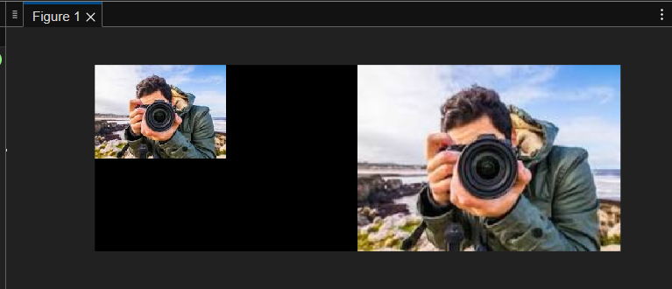

Question no 2:
Rot=imroatate(I,35,’bilinear’)
Imshow(rot)

Output:
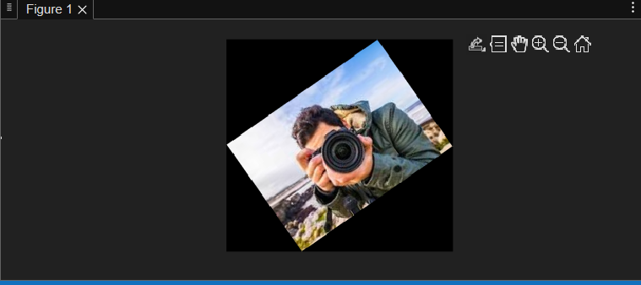
% Create a binary image
bw = zeros(5,5);
bw(2,2) = 1;
bw(4,4) = 1;

% Distance transforms using different methods
D1 = bwdist(bw,'euclidean');
D2 = bwdist(bw,'cityblock');
D3 = bwdist(bw,'chessboard');
D4 = bwdist(bw,'quasi-euclidean');

% Display results
figure

subplot(2,2,1)
imshow(D1,[])
title('Euclidean Distance')

subplot(2,2,2)
imshow(D2,[])
title('Cityblock Distance')

subplot(2,2,3)
imshow(D3,[])
title('Chessboard Distance')

subplot(2,2,4)
imshow(D4,[])
title('Quasi-Euclidean Distance')

OUTPUT:
